ASSIGNMENT 25

Name : Akanksha Joshi

Roll No : B038

Batch : 3

Div : BTech CS B

--------------------------------------------------------------------------------------------------------------------------

Q. Consider the scenario from “Variety Retail Store” discussed in “List” section. The list of furniture available with its respective cost is given below :

Furniture Sofa set Dining Table T.V. Stand Cupboard

Cost in Rs. 20,000 8,500 4,599 13,920

A customer can order any furniture in any quantity , if the required furniture is available in the furniture list ( given above ) and quantity to be purchased is greater than zero, then bill amount should be calculated . In case of invalid values for furniture required by the customer and quantity to be purchsed, display appropriate error message and consider bill amount to be 0. Initialise required furniture and quantity and different values and test the results.

Calculate and display the bill amount to be paid by the customer based on the furniture bought and quantity purchased. Implement the given scenario using :

1. List of tuples
2. Dictionary

Source Code

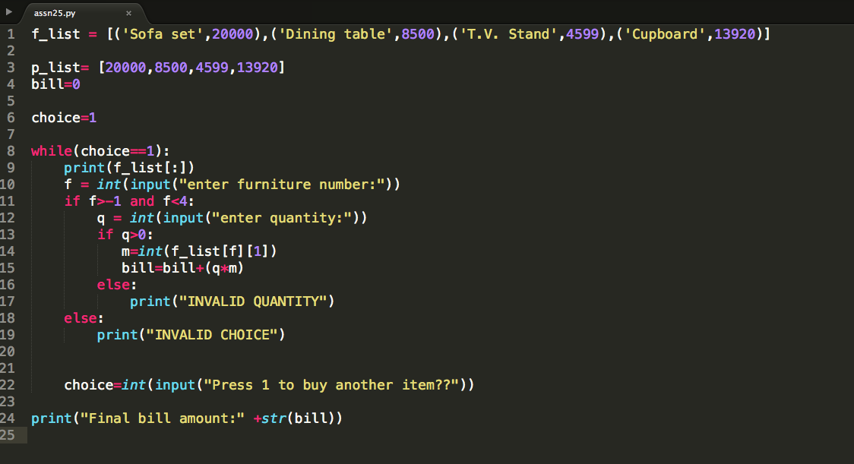

Output:

[('Sofa set', 20000), ('Dining table', 8500), ('T.V. Stand', 4599), ('Cupboard', 13920)]

enter furniture number:2

enter quantity:5

Press 1 to buy another item??1

[('Sofa set', 20000), ('Dining table', 8500), ('T.V. Stand', 4599), ('Cupboard', 13920)]

enter furniture number:1

enter quantity:1

Press 1 to buy another item??0

Final bill amount:31495